Alternatives for starting Oracle access
- Use Oracle SQL*Plus at Selkirk College:

User Name: first initial and last name
(one word-omit spaces, hyphens and apostrophes)
Password: same as username
Host String: sgrcdev

- Use iSQL*Plus at Selkirk College:

Use your browser to go to: http://ora1:5560/isqlplus/

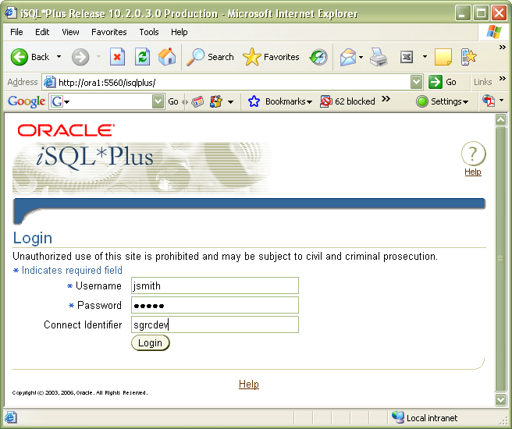
1. enter URL
2. enter username
3. password same as username
4. connection identifier required

- Use iSQL*Plus from home
Like #2 above, but with the following URL: http://199.60.147.26:5560/isqlplus

